Forecasting German Electricity Demand: A Comparative Evaluation of Benchmark, SARIMAX, Feature-Based and LSTM Models
Name: Sai Subramanya Teja Sarvade Student ID: 24090920
Github link : https://github.com/Subbu-coder13/TIME-SEIRES-MODEL-CASE-STUDY
1. Introduction
Short- and medium-term electricity load forecasting remains central to power-system operations. Accurate demand projections support unit commitment, reserve planning and the integration of variable renewable generation. This case study concentrates on Germany (country identifier DE in the Open Power System Data archive) and addresses a practical research question: on a genuine multi-year hold-out period, do standard statistical and machine-learning models improve on a strong seasonal benchmark?
The workflow follows the assignment structure. Weekly average demand is explored and tested for non-stationarity. Four classical benchmarks (mean, naïve, seasonal naïve and drift) establish a two-year baseline. A seasonal ARIMA model is selected by AIC over the full (p, d, q) grid required by the brief. Temperature and holiday covariates are then added in a SARIMAX specification. The same weekly series is modelled with a feature-based gradient boosting regressor under a leakage-aware recursive forecast. Finally, an LSTM is trained on hourly load and compared with an hourly seasonal naïve forecast. Evaluation uses MAE, RMSE, MASE and Bias, with explicit discussion of conditional versus operational temperature forecasts.
2. Data and preprocessing
Hourly German electricity load was obtained from the Open Power System Data 60-minute single-index file, using the ENTSO-E transparency series DE_load_actual_entsoe_transparency. Observations from 1 January 2015 onwards were retained, giving continuous coverage through early October 2020. After removing missing hourly values, approximately 50,400 hourly observations remained.
For weekly modelling the series was aggregated to week-ending means and converted from MW to GW. The resulting weekly target comprises 301 observations (4 January 2015 to 4 October 2020). A parallel daily mean series was retained for exploratory plots. Weekly gaps were filled by time interpolation where needed so that a regular weekly frequency could be used with seasonal models.
Berlin was used as a representative climate location. Daily mean 2 m temperature was retrieved from the Open-Meteo archive API and aggregated to weekly means, minima and maxima, together with heating- and cooling-degree sums (bases 15.5°C and 22°C). German public holidays were summarised as weekly holiday counts and a binary holiday indicator. The merged modelling table therefore contains load, temperature features and holiday covariates at weekly frequency.
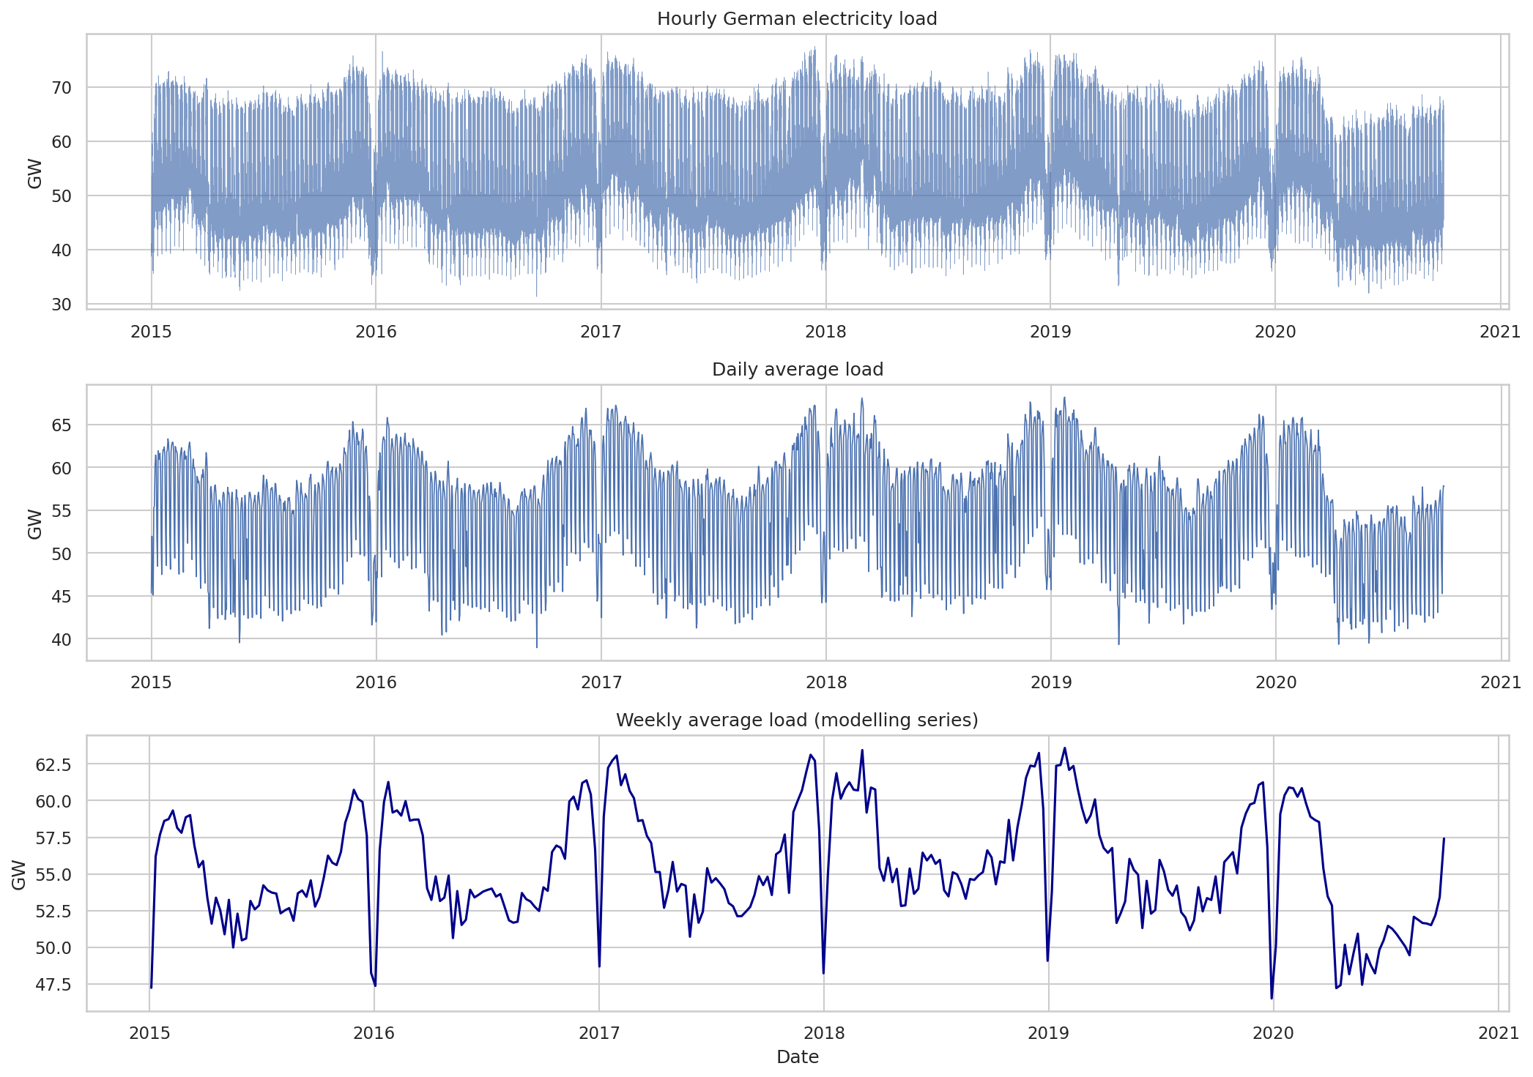
Figure 1. Hourly, daily and weekly German electricity load (2015–2020).
Figure 1 shows winter peaks, summer troughs and a slowly evolving level. Weekly averaging smooths diurnal and weekday effects while retaining the dominant annual cycle used in Parts 2–5.
3. Exploratory analysis and non-stationarity
3.1 Seasonal structure and time-series components
STL decomposition of weekly load with period 52 isolates a clear annual seasonal component superimposed on a slowly changing trend (Figure 2). Autocorrelation functions reinforce this reading: the ACF of the weekly series remains elevated at seasonal lags, and ACF/PACF plots of first differences continue to show structure near lag 52 (Figure 3). Hourly data additionally embed diurnal and weekly cycles, which later motivates LSTM sequence lengths of 24 or 168 hours.
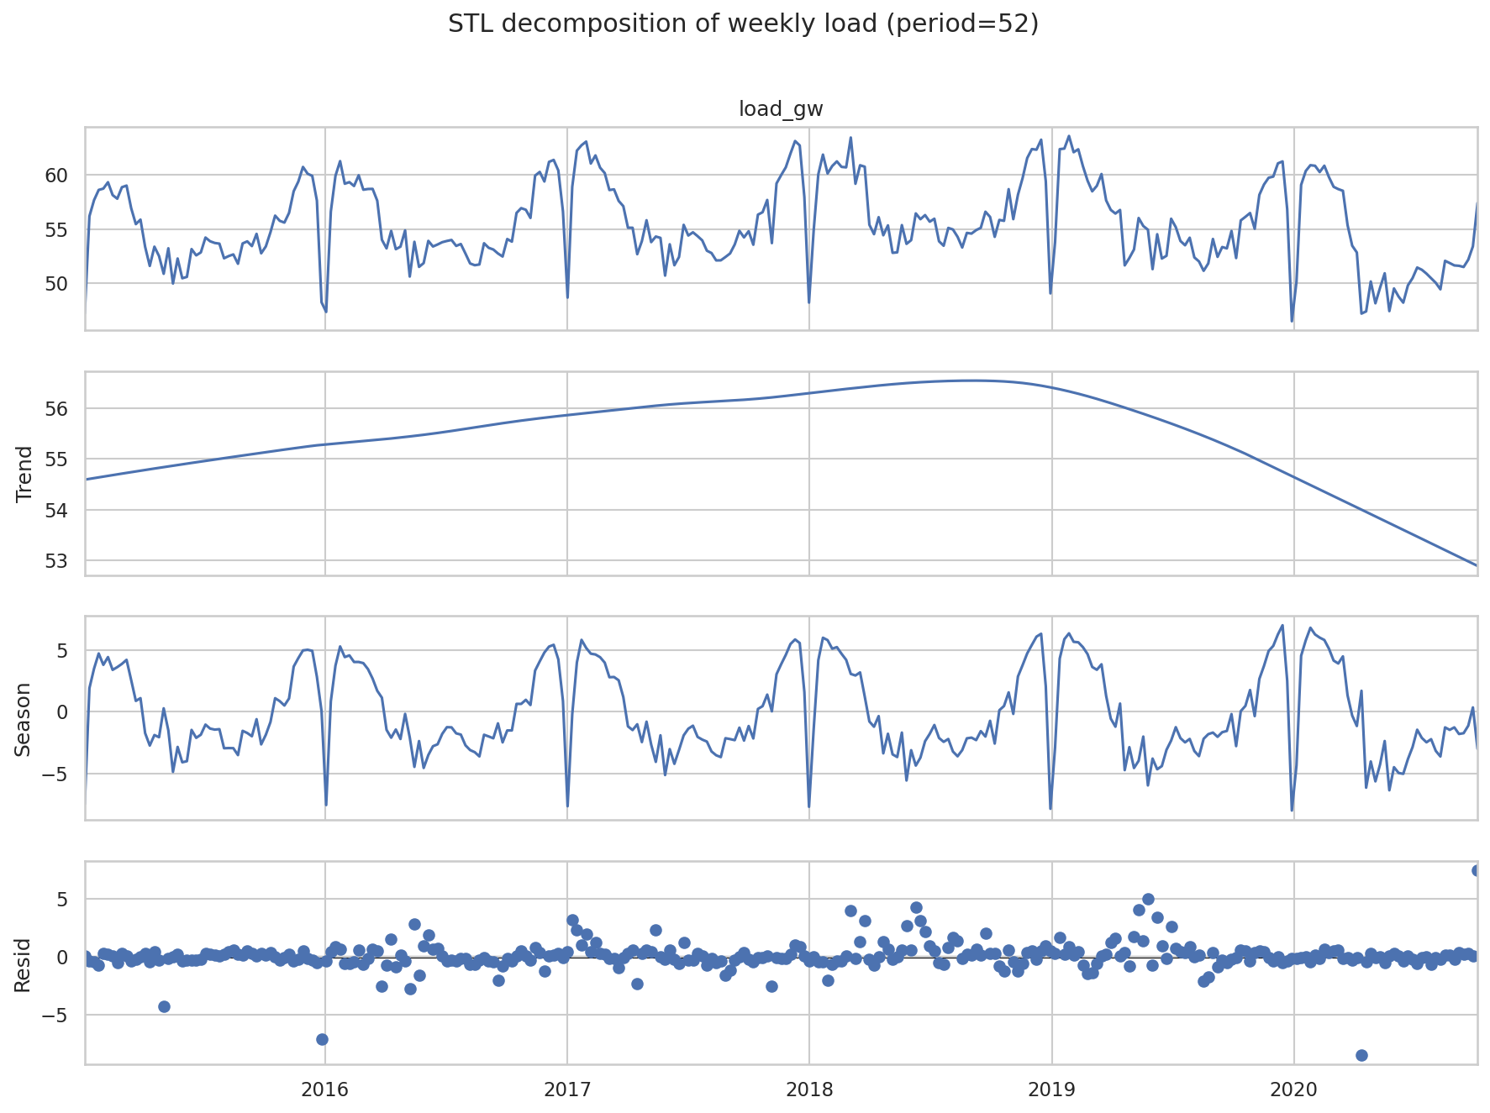
Figure 2. STL decomposition of weekly average load (period = 52).
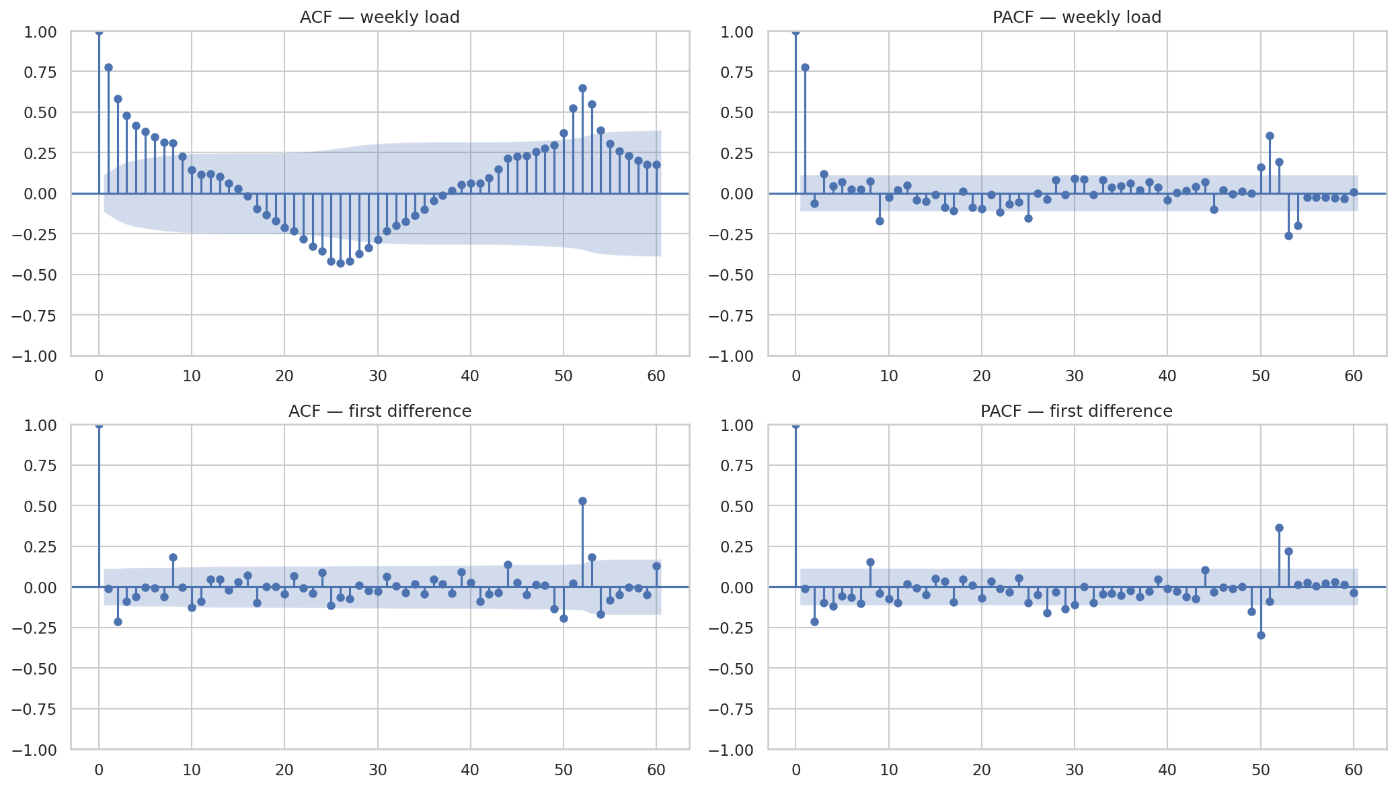
Figure 3. ACF and PACF of weekly load (level and first difference).
Conclusion for the brief: the weekly series has a strong seasonal component with period approximately one year (52 weeks), together with trend and irregular residual variation.
3.2 Stationarity tests
Augmented Dickey–Fuller (ADF) and KPSS tests were applied to the weekly level, first difference and seasonally differenced series:
Series | Test | Statistic | p-value | Stationary @ 5%?
Weekly level | ADF | −4.05 | 0.0012 | Yes (reject unit root)
Weekly level | KPSS | 0.16 | 0.10 | Yes (fail to reject)
First difference | ADF | −7.07 | ≈ 0 | Yes
Seasonal difference | ADF | −4.30 | 0.0005 | Yes
Seasonal difference | KPSS | 1.34 | 0.01 | No (KPSS)
Level tests do not by themselves force first differencing. The seasonal ACF pattern and SARIMA practice still motivate seasonal differencing D = 1 with period 52. Non-seasonal d was left free in the AIC search.
4. Forecasting methods
4.1 Benchmark models
Four benchmarks discussed in lecture material were computed on a 104-week (two-year) test window: mean forecast, naïve (last observation carried forward), seasonal naïve (same week one year earlier, lag 52) and drift. Seasonal naïve is treated as the primary benchmark because electricity demand is strongly yearly. Forecasts use training history only and do not update using future observed test load, preventing evaluation leakage.
4.2 SARIMA with AIC grid search
Seasonal ARIMA models were estimated with statsmodels. Seasonal structure was fixed at (P, D, Q, s) = (1, 1, 1, 52) following the EDA, while non-seasonal orders were searched exhaustively over p ∈ {0,…,6}, d ∈ {0,1,2} and q ∈ {0,…,6} (147 candidates). Selection used training AIC only. Residual diagnostics comprised residual plots, histograms and residual ACF. Forecasts include 80% and 95% prediction intervals.
4.3 SARIMAX with temperature and holidays
The preferred SARIMA orders were re-estimated with exogenous regressors: temp_mean, heating_degree, cooling_degree, holiday_days and has_holiday. Ablations without holidays and without any exog were retained. Because test-period temperatures were observed archive values rather than weather forecasts, SARIMAX forecasts are reported as conditional (explanatory) forecasts, not fully operational forecasts.
4.4 Feature-based model
A HistGradientBoostingRegressor used lag features (1, 2, 4, 8, 13, 26, 52), rolling means computed after a one-step shift, calendar/Fourier terms, and the same temperature and holiday covariates. Multi-step forecasts over 104 weeks were recursive: each prediction is appended to history before constructing the next week’s lag features, so future observed load cannot leak into predictors.
4.5 LSTM on hourly data
An LSTM was trained on hourly load (MW) with MinMax scaling fitted on the training window only. A small validation grid compared sequence lengths 24 and 168 hours and 32/64 units. The selected configuration was seq_len = 168, units = 32, one LSTM layer. Predictions for the final two years of hours used recursive one-step rollouts. LSTM use for load forecasting is supported by Hossain et al. (2020) and reviewed by Nabavi et al. (2024); those studies typically emphasise shorter horizons than a two-year recursive path.
5. Evaluation design
All weekly models share the same chronological split: training ends 7 October 2018; testing runs 14 October 2018 to 4 October 2020 (104 weeks). For hourly models the last 17,520 hours form the test window. Accuracy metrics are MAE, RMSE, MASE and Bias. MASE scales absolute errors by in-sample seasonal-naïve error (seasonality 52 weekly; 168 hours for hourly models), allowing dimensionless comparison against the seasonal benchmark (Hyndman and Koehler, 2006).
Leakage controls: chronological split only; AIC and scaler fitted on training data; load lags via shift/rolling-on-shifted values; recursive multi-step ML/LSTM forecasts; realised test temperatures labelled as conditional information.
6. Results
6.1 Benchmark forecasts
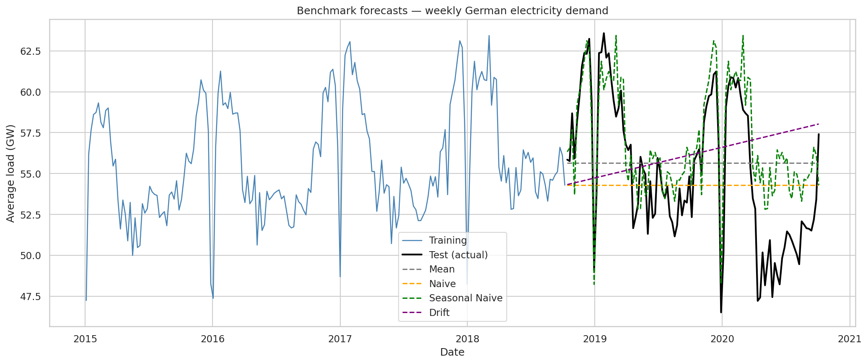
Figure 4. Two-year benchmark forecasts versus actual weekly load.
Model | MAE (GW) | RMSE (GW) | MASE | Bias (GW)
Seasonal naïve | 2.319 | 3.007 | 1.732 | 1.732
Naïve | 3.783 | 4.459 | 2.827 | −0.882
Mean | 3.789 | 4.397 | 2.831 | 0.481
Drift | 4.340 | 5.118 | 3.243 | 1.007

Seasonal naïve dominates the other simple rules. Mean and naïve forecasts miss annual timing; drift adds little beyond a level offset. Positive seasonal-naïve bias in 2018–2020 (including COVID-affected 2020) shows over-prediction on average, yet within-year shape tracking remains strong.
6.2 SARIMA selection, residuals and forecast
All 147 (p, d, q) candidates converged. The minimum-AIC model was SARIMA(4,0,6)×(1,1,1)₅₂ with AIC ≈ 302.73. Nearby competitors included (1,1,6)×(1,1,1)₅₂ (AIC ≈ 303.50) and (4,1,6)×(1,1,1)₅₂ (AIC ≈ 303.59).
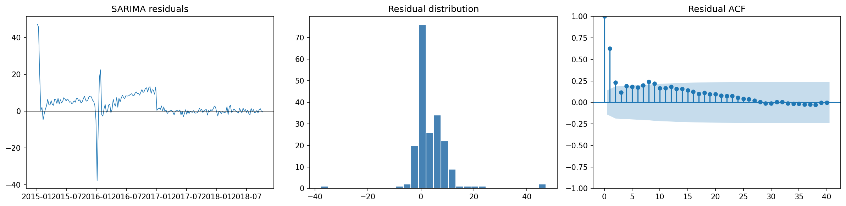
Figure 5. SARIMA residual time series, histogram and residual ACF.
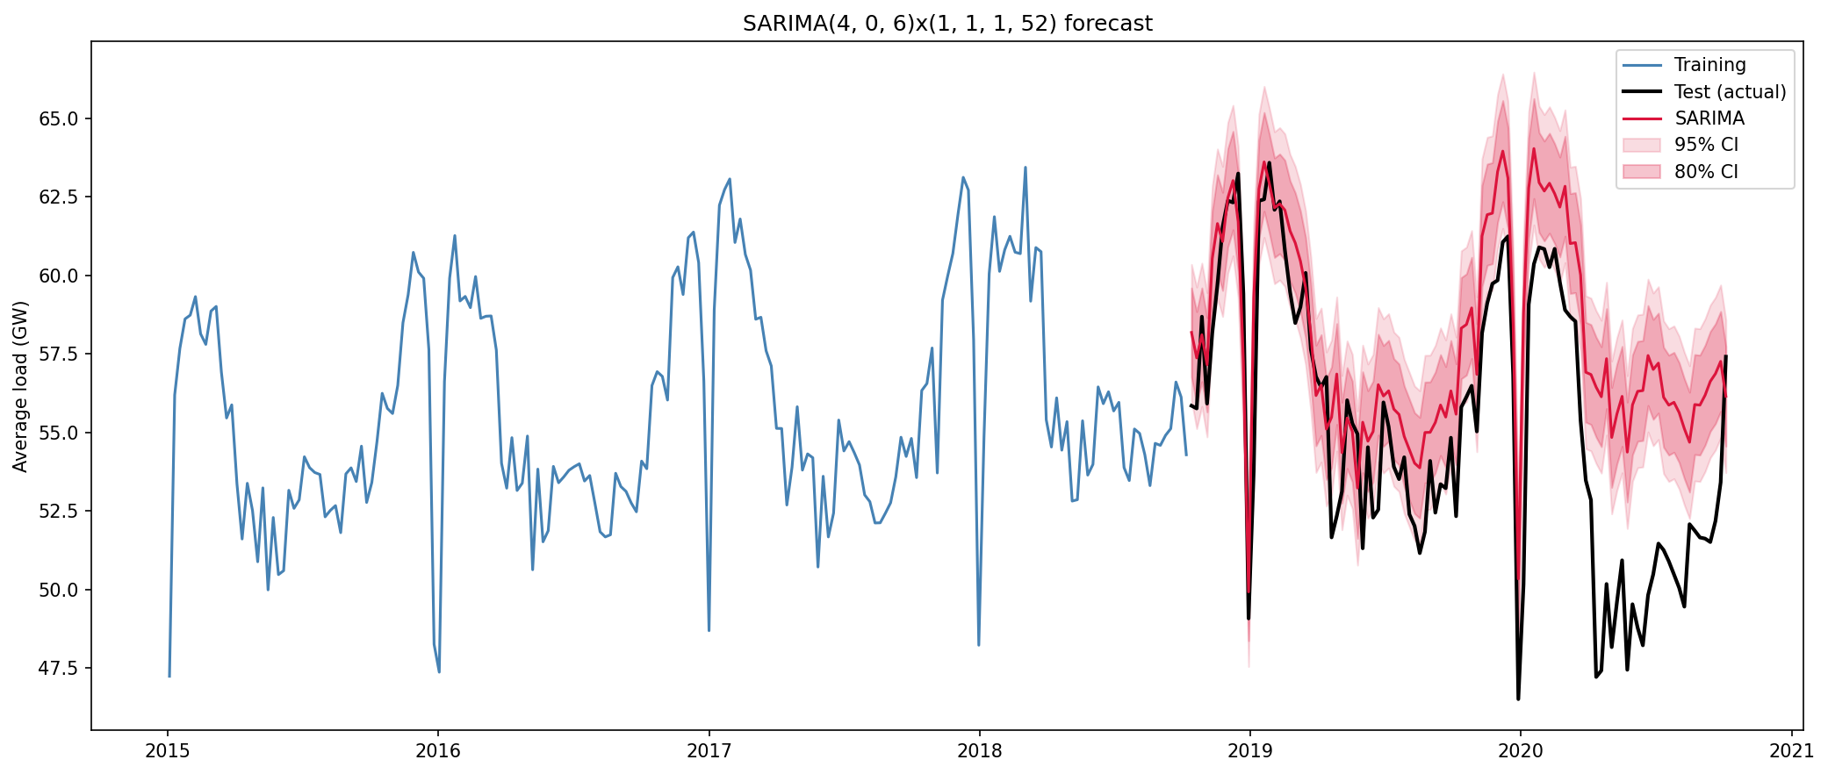
Figure 6. SARIMA forecast with prediction intervals over the 104-week test set.
On the test set, SARIMA MAE ≈ 3.017 GW and MASE ≈ 2.254 — worse than seasonal naïve. Residuals are roughly centred but retain some serial dependence. The multi-step forecast carries a large positive bias (≈ +2.79 GW). A flexible in-sample AIC fit therefore did not guarantee superior long-horizon accuracy.
6.3 SARIMAX: temperature and holiday covariates
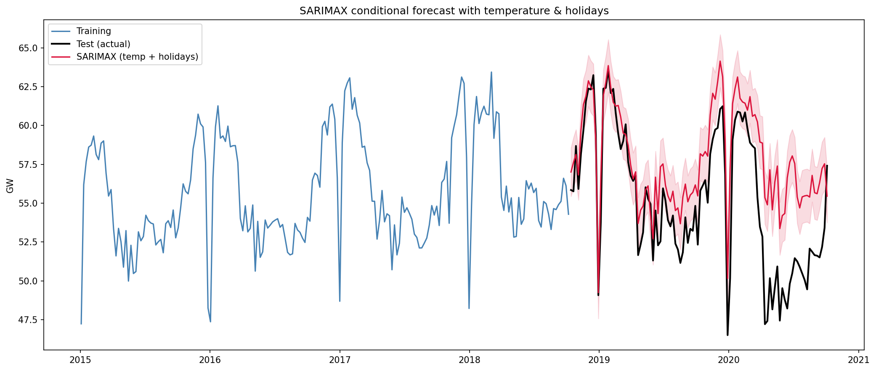
Figure 7. Conditional SARIMAX forecast using temperature and holiday regressors.
Model | MAE | RMSE | MASE | Bias
SARIMAX (no exog) | 3.018 | 3.729 | 2.255 | 2.785
SARIMAX (temperature) | 2.802 | 3.589 | 2.094 | 2.580
SARIMAX (temp + holidays) | 2.782 | 3.513 | 2.079 | 2.652

Temperature features improve SARIMAX relative to the unaugmented model; holidays add a further small gain. Relative to seasonal naïve, however, even the richest SARIMAX remains about 20% worse on MAE. Covariates help within the SARIMAX family without overturning the seasonal benchmark on this horizon.

6.4 Feature-based gradient boosting
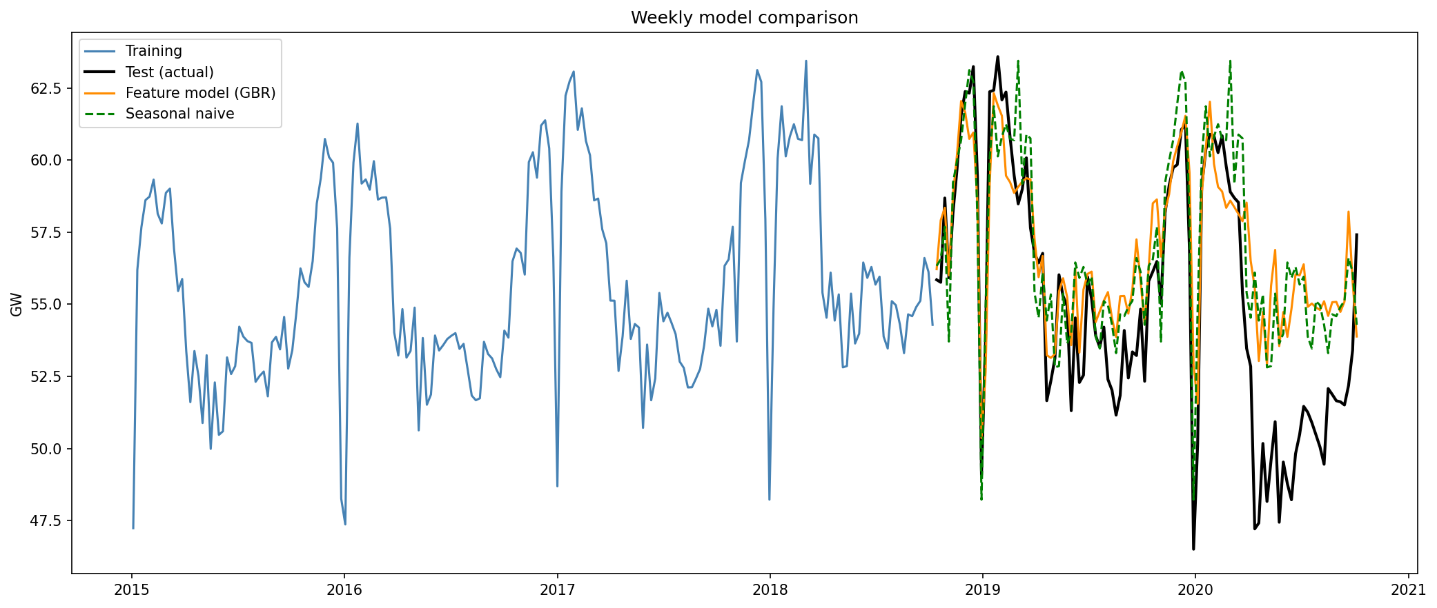
Figure 8. Weekly comparison of seasonal naïve and the feature-based model against actual load.
The gradient boosting model achieves MAE 2.219 GW, RMSE 2.962, MASE 1.658 and bias 1.638. It is the only weekly method that improves on seasonal naïve (about 4.3% lower MAE). The gain is modest, which is informative: when annual seasonality is stable, tree ensembles mainly refine residual seasonal and weather-driven fluctuations rather than rewriting the yearly template.
6.5 LSTM hourly forecasts
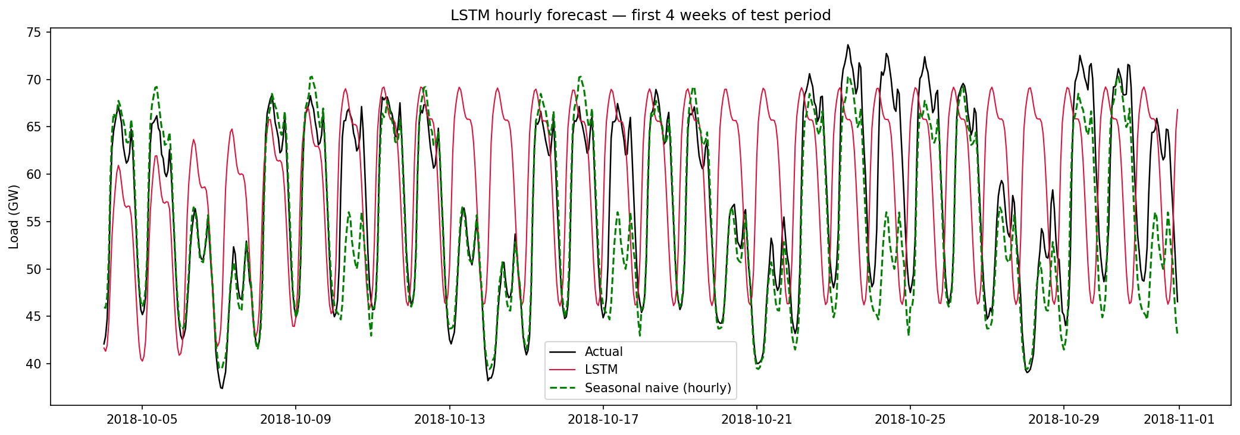
Figure 9. LSTM versus hourly seasonal naïve — first four weeks of the test period.
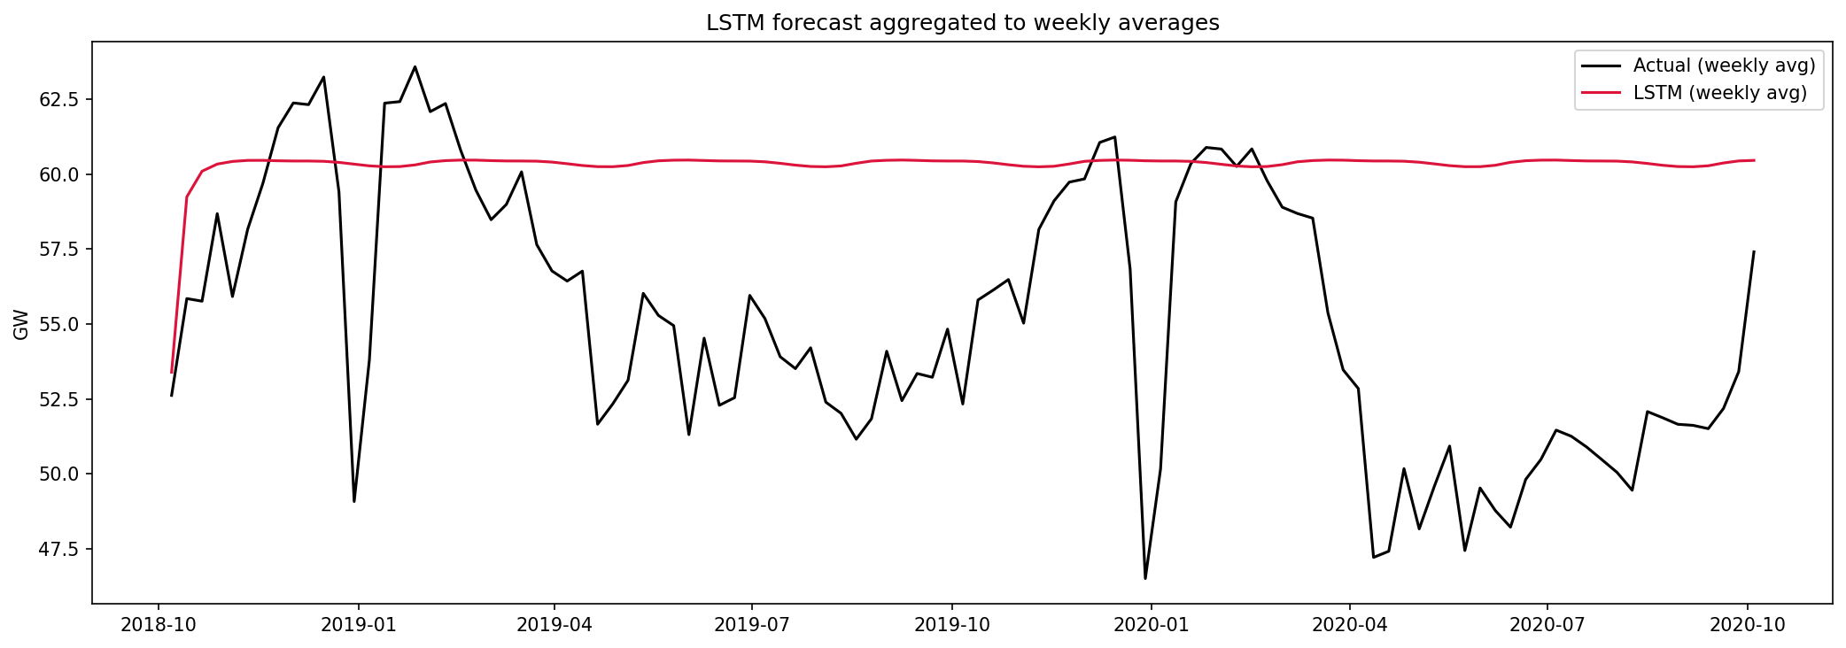
Figure 10. LSTM hourly forecasts aggregated to weekly means.
Model | MAE (MW) | RMSE (MW) | MASE | Bias
Hourly seasonal naïve (s=168h) | 5,133 | 6,736 | 2.224 | −293
LSTM | 11,277 | 13,770 | 4.886 | +5,191

Validation favoured seq_len = 168 with units = 32. Recursive forecasting over ≈17,500 hours compounds one-step errors; the LSTM overshoots systematically and fails to beat a lag-of-one-week hourly rule. Weekly aggregation (Figure 10) does not reverse that conclusion.
6.6 Combined weekly evaluation table
Rank | Model | MAE | RMSE | MASE | Bias
1 | Feature model (GBR) | 2.219 | 2.962 | 1.658 | 1.638
2 | Seasonal naïve | 2.319 | 3.007 | 1.732 | 1.732
3 | SARIMAX (temp + holidays) | 2.782 | 3.513 | 2.079 | 2.652
4 | SARIMAX (temp) | 2.802 | 3.589 | 2.094 | 2.580
5 | SARIMA / no-exog SARIMAX | ≈3.017 | ≈3.728 | ≈2.254 | ≈2.785
6 | Naïve | 3.783 | 4.459 | 2.827 | −0.882
7 | Mean | 3.789 | 4.397 | 2.831 | 0.481
8 | Drift | 4.340 | 5.118 | 3.243 | 1.007

7. Discussion (assignment analysis questions)
7.1 Comparison with the seasonal naïve benchmark
Only the feature-based GBR provides a meaningful—though small—improvement over seasonal naïve (MAE 2.22 vs 2.32 GW; MASE 1.66 vs 1.73). SARIMA, all SARIMAX variants, mean/naïve/drift and the LSTM fail to beat the corresponding seasonal naïve benchmarks. The result reflects both the strength of yearly electricity seasonality and the difficulty of a single two-year multi-step evaluation.
7.2 Avoiding data leakage with lag and temperature features
Load lags were created with positive shifts; rolling statistics used a one-step shift before smoothing. Multi-step GBR predictions never consulted future observed load when constructing subsequent features. Temperature entered as an exogenous covariate: using realised temperature in the test window does not leak the load target, but it assumes weather information that would, in operations, come from a forecast. That assumption is disclosed by labelling weather-aware forecasts as conditional.
7.3 Differencing orders and seasonal period for SARIMAX
The seasonal period s = 52 follows from weekly sampling of an annual cycle (STL/ACF). Seasonal differencing D = 1 removes that yearly pattern. The AIC search selected d = 0 with (p, q) = (4, 6); nearby models with d = 1 had only marginally worse AIC, so extra non-seasonal differencing was not strongly required once seasonality was handled. Seasonal ARMA terms were held at (1,1) given the assignment’s emphasis on searching (p,d,q) and the computational cost of a full seasonal grid with s = 52.
7.4 Temperature and holiday covariates
Within SARIMAX, temperature clearly helps and holidays add a further small improvement (MAE 3.02 → 2.80 → 2.78 GW), but accuracy remains below seasonal naïve. Holiday indicators are known at the forecast origin and are valid future covariates. Temperature is not known with certainty; realised values yield a conditional forecast, whereas an operational pipeline would substitute numerical weather prediction and inherit weather-forecast error.
7.5 Interpretability and complexity
SARIMAX offers the clearest narrative: autoregressive memory, seasonal differencing and signed weather/holiday coefficients. The GBR is intermediate—feature importance can be inspected, but dynamics are not a closed-form difference equation. The LSTM is the least interpretable and, here, the least competitive. Complexity therefore rises from SARIMAX → GBR → LSTM, while weekly accuracy peaked at GBR.

7.6 Operational recommendation
For operational weekly forecasting I recommend the feature-based gradient boosting model, supported by a continuously updated seasonal naïve monitor. GBR alone improved hold-out MAE/MASE; it is inexpensive to retrain weekly and its inputs are understandable to operators. Seasonal naïve remains an essential fallback and audit benchmark. SARIMAX is attractive when formal prediction intervals and coefficient interpretation are required, provided temperature is sourced from weather forecasts (or omitted). The present LSTM configuration is not recommended for a two-year recursive hourly product; neural models are better reserved for shorter horizons where recursive drift is limited.
8. Limitations and future improvements
A single fixed origin with a 104-week horizon stresses multi-step methods; rolling-origin evaluation would better reflect short-horizon SARIMA and LSTM skill. The test window overlaps COVID-19 demand shifts in 2020, which may inflate and redistribute errors. Temperature enters as a conditional input; replacing it with lagged weather forecasts would stress-test operational value. Prediction intervals were produced for SARIMA/X but not for GBR; conformal calibration or quantile forests would close that gap. Future work could explore hybrid forecasts (seasonal naïve or SARIMA level plus ML residual correction) and shorter-horizon LSTM day-ahead experiments closer to settings emphasised by Hossain et al. (2020).
9. Conclusion
This case study modelled German electricity demand from 2015 to 2020 using benchmarks, AIC-tuned SARIMA/SARIMAX, a recursive feature-based gradient booster and an hourly LSTM. Exploratory analysis confirmed a dominant annual seasonal component. On a two-year hold-out set, seasonal naïve proved difficult to beat: only the feature-based model achieved a modest improvement (MAE 2.22 GW versus 2.32 GW). Temperature and holiday covariates improved SARIMAX relative to an unaugmented specification but not relative to the seasonal benchmark, and realised temperatures imply a conditional rather than fully operational forecast. The LSTM underperformed an hourly seasonal naïve rule under long recursive evaluation. For operational weekly forecasting, the results favour a maintained GBR with seasonal naïve as the reference and fallback.
References
Box, G.E.P., Jenkins, G.M., Reinsel, G.C. and Ljung, G.M. (2015) Time Series Analysis: Forecasting and Control. 5th edn. Wiley.
Hong, T. and Fan, S. (2016) ‘Probabilistic electric load forecasting: A tutorial review’, International Journal of Forecasting, 32(3), pp. 914–938.
Hossain, M.S. and Mahmood, H. (2020) ‘Short-term load forecasting using an LSTM neural network’, IEEE Power and Energy Conference at Illinois (PECI).
Hyndman, R.J. and Athanasopoulos, G. (2021) Forecasting: Principles and Practice. 3rd edn. Melbourne: OTexts. Available at: https://otexts.com/fpp3/
Hyndman, R.J. and Koehler, A.B. (2006) ‘Another look at measures of forecast accuracy’, International Journal of Forecasting, 22(4), pp. 679–688.
Nabavi, S.A. et al. (2024) ‘Deep learning modeling in electricity load forecasting: a review’, Energy Reports.
Open Power System Data (2020) Time series data package (version 2020-10-06). Available at: https://data.open-power-system-data.org/time_series/
Zippenfenig, P. / Open-Meteo (2023) Open-Meteo Weather API. Available at: https://open-meteo.com/

